E.W. THURSTON MIDDLE SCHOOL
5TH Grade Parents’ Night
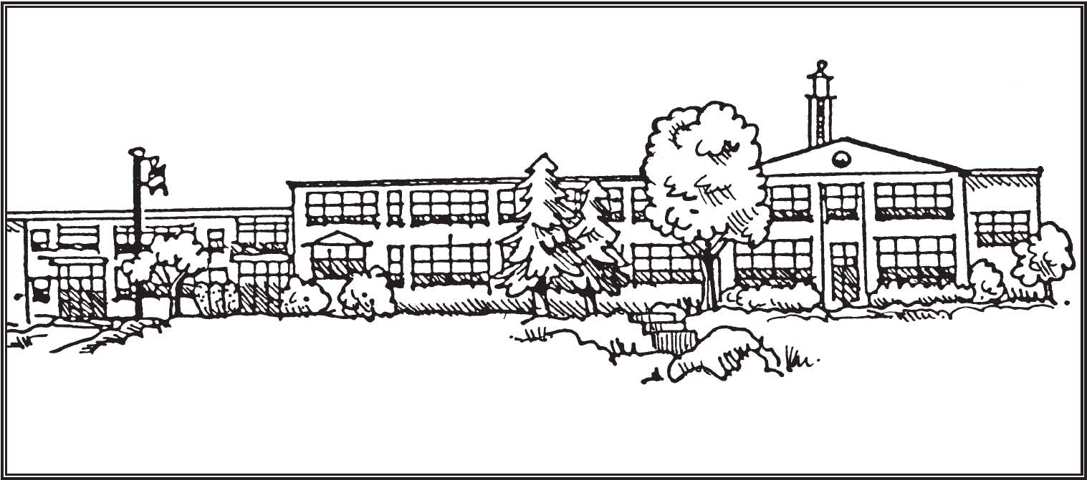
Thursday, May 3, 2018

6:30 PM Presentation in the Auditorium
7:30 PM Coffee, cookies and Q&A in the Cafeteria
Explore the building

Representatives from Thurston’s PTO will be on hand, so you can learn about volunteer opportunities and pre-pay 2018-2019 dues.
Sign-up information for buses and cross-country will also be available.

Questions? Please contact the main office at Thurston Middle School.
(781) 326-7500 x2336

