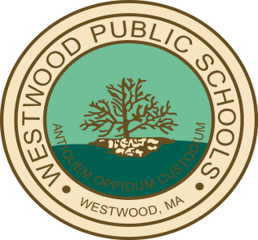
WESTWOOD PUBLIC SCHOOLS

Bus Registration for 2019-2020 begins March 1st and ends June 30th

Bus Stickers are no longer issued to Middle and High School Students. All Drivers will have a list of Registered Students. At the end of August, the Bus Routes will be posted on the District Website. Please check the Aspen Portal to see what Bus # your child(ren) have been assigned to.

The annual bus fee for 2019-2020 will be $180.00 per student. The annual family cap will remain at $450.00 for all students in grades K-12.

Online Bus Registration
If you are interested in Bus Transportation for your child, please visit the Westwood Public Schools’ website at www.westwood.k12.ma.us
and click on, On-Line Payments, Bus Transportation Registration & Payment. After reading the FAQ’s, you can Register and pay online for Transportation.
To guarantee a seat on the bus, registration and payment must be received by the June 30th deadline.

Parents will need their child’s Student ID # (except for Kindergarten) which can be found on elementary school lunch invoices, middle school lunch cards, report cards or high school ID cards. Please make sure to enter the grade your child will be entering next September.

Sincerely,
Heath Petracca
Director of Business & Finance

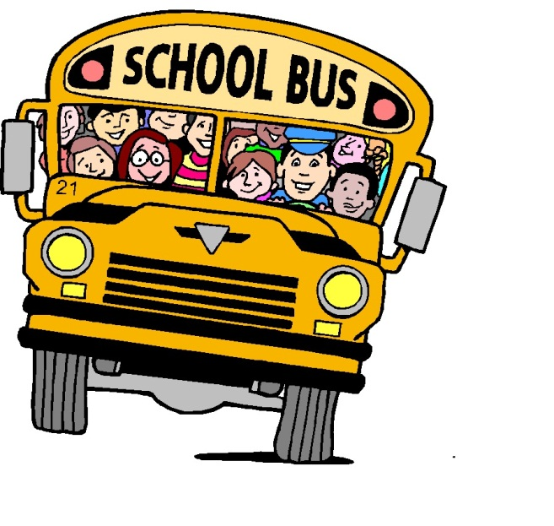

g
No Need to Wait!
Sign up now online for next fall.

Transportation rates will not be increasing for the 2019-2020 school year.

If you have any questions regarding bus registration, please email
busregistration@westwood.k12.ma.us
or call the business office 781-326-7500, x1343

All Registrations and Payments are due by June 30th

