Breakfast

Continental – assortment of house made Muffins, Danish, Filled Croissants, Scones and more **$3.50pp**

Parfait Bar – Vanilla or Strawberry Yogurt, Assorted Berries, Home Made Granola

**$4.00pp**

Fruit Bar – A Variety of Sliced Fruit, Melons, Berries served with Yogurt **$4.00pp**

Cereal Buffet – A Variety of Cereals, served with Bananas and Berries and Milk **$3.00pp**

*\*Gluten Free Options and Other Allergen Free Items are available. Please Inquire at Time of Ordering*

Beverages

The CTD – Coffee, Tea, Decaf – Variety of sugars, ream, milk, teas, cups, lids, stirrers and more… **$2.00pp**

***Bottled Juice*** - **$2.00pp**

***Bottled Water*** – 8oz **$1.00pp** ***Bottled Water*** – 16oz **$1.50pp**

***Soda*** – Coke products **$2.00pp**

*\*Gluten Free Options and Other Allergen Free Items are available. Please Inquire at Time of Ordering*

Lunch

***The Platter*** – Variety of Sandwiches (Choose 3 from List Below). Includes: Chips, Hand Fruit, Cookie Platter All Sandwiches come dressed with Lettuce and Tomato. Condiments and pickles are on the side*Turkey, Ham, Roast Beef, Roasted Vegetables, Tuna Salad, Chicken Salad, Grilled Chicken.*  **$10.00pp**

***Finger Roll Mini’s –*** Assortment of Tuna salad, Chicken Salad, Ham Salad, Turkey Salad served in Finger Rolls Includes: Chips, Hand Fruit, Cookie Platter **$9.00pp**

***Specialty Platter*** – Choose (3) from *Turkey Club on Bulkie*, *Roast Beef Horseradish Crème and Cheddar on Brioche*, *Ham and Swiss Dijonaise* *on Croissant, Italian on Ciabatta, Chicken Caesar Wrap.* Includes: Chips, Hand Fruit, Cookie Platter **$12.00pp**

***Tex Mex Buffet*** – Choose from Fajita, Taco or Burrito Buffet. Includes: Choice of 2 Chicken, Steak, Pork or Vegetables. Traditional Accompaniments for each buffet, including but not limited to; Salsa, Sour Cream, Shredded Lettuce, Mexican Street Corn, Beans Borracho, and more. **$12.00pp**

***The North End*** – Penne Pasta tossed with Marinara or Alfredo Sauce. Choose from Chicken Parm or Meatballs. Also included Roasted Vegetables, Caesar Salad, and Bread Stick **$14.00pp**

***Mediterranean Mezze*** – An array of Mediterranean Specialties including, Hummus, Tabbouleh, Tapenade, Tzatziki, Olives, Roasted Red Peppers, Artichoke hearts, Cheeses, Pita, breads, and Spreads **$11.00pp**

*\*Gluten Free Options and Other Allergen Free Items are available. Please Inquire at Time of Ordering*

Salads

***All Prices for Salads Based on 10 Guests***

***Garden Salad-*** Chopped Greens, Tomatoes, Olives, Red Onion, Cucumber and Shredded Carrots, House Italian Vinaigrette **$5.00pp**

***Greek Salad –*** Chopped Greens, Feta Cheese, Pepperoncini, Olives, Tomatoes, Cucumber, Red Onion, Greek Dressing **$6.00pp**

***Caesar Salad –*** Chopped Romaine Lettuce, Parmesan Cheese, Crunchy Croutons, Caesar Dressing **$5.00pp**

***Asian Salad –*** Mixed Greens, Tomatoes, Cucumbers, Carrots, Red Pepper, Fresh Cilantro, Crispy Wonton Strips, Ginger Soy Dressing **$6.00pp**

***Southwest Salad –*** Mixed Greens, Roasted Corn, Black Beans, Red Onions, Diced Tomatoes, BBQ Ranch Dressing **$6.00pp**

***Caprese –*** Fresh Sliced Mozzarella, Fresh Sliced Tomatoes, Fresh Basil, Balsamic Vinaigrette **$6.00pp**

***Pasta Salad –*** Traditional **$2.50pp**

***Potato Salad –*** Traditional or German **$2.50pp**

***Cole Slaw –*** Traditional or Southwest **$2.50pp**

***Potato Chip –*** Lay’s original **$1.50pp**

***Hummus and Pita –*** House Made **$3.50pp**

***Fruit Salad –*** Fresh cut **$2.50pp**

*\*Gluten Free Options and Other Allergen Free Items are available. Please Inquire at Time of Ordering*

To place a catering order please use the Catering Request Form

that was sent to the district thru email.

Email: [food@westwood.k12.ma.us](mailto:food@westwood.k12.ma.us)

*MANAGEMENT STAFF*

*Food Service Director:* Michael DiMascio

*Food Service Manager:* Jeanne Destito

*Executive Chef:* Bill Berman

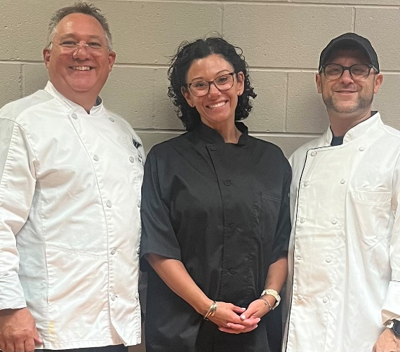

*\*Gluten Free Options and Other Allergen Free Items are available. Please Inquire at Time of Ordering*

NOTES:

* Please try to give at minimum 7 business day notice for all events
* We will do our very best to provide you with the highest quality food, service, and pricing
* Use our menu as a guide, we can create and provide most menu requests
* We are able to accommodate most allergy requests. We are not an allergen free kitchen but we do take care in keeping allergen meals separate from the rest.

ADDITIONAL FEES:

* Labor charges will be added for any event that requires an attendant during school hours or if the event is after school hours or evenings.
* A service fee of 10% will be added to the total invoice for supplies needed for the event
* An added service fee of 10% will be added to the total invoice for any extra kitchen equipment that is needed at the delivery site (Warming boxes, chafers, coolers, etc.) 

*\*Gluten Free Options and Other Allergen Free Items are available. Please Inquire at Time of Ordering*



CAFÉ WEST

Westwood Public Schools

Food Services

Catering Menu



**Phone: 781-326-7500 ext. 4351**