Massachusetts Department of

Elementary and Secondary Education

75 Pleasant Street, Malden, Massachusetts 02148-4906 Telephone: (781) 338-3000

TTY: N.E.T. Relay 1-800-439-2370

MEMORANDUM

To: | School Administrators and School Nutrition Directors
From: | Robert M. Leshin, Acting Director  Office for Food and Nutrition Programs
Date: | June 16, 2016
Subject: | SY 2016-2017 Massachusetts New Meal Benefit Household Application packet  Important  Program Action Required  SY 2016-2017 New Meal Benefit Application packet  SY 2016-2017 Income Eligibility Guidelines
The NEW Massachusetts prototype School Year 2016-2017 Free and Reduced Priced School Meals Household Application Packet, including all meal benefit issuance and verification forms, is currently available. The School Year 2016-2017 Income Eligibility Guidelines document is also available. Massachusetts prototype documents are derived from USDA prototype materials found at http://www.fns.usda.gov/revised-prototype-free-and-reduced-price-application-materials-sy-2016-17. Please reference SP 34-2016 entitled Revised Prototype Free and Reduced Price Application Materials: Policy Changes and Design Overview. Massachusetts prototype materials are found in the Document and Reference Library of the ESE Security Portal under NSLP 2017 Meal Benefit Issuance Application Documents. The Healthy, Hunger-Free Kids Act of 2010 continues to make changes to the meal benefit issuance process. The attached forms are recommended for use as they include all mandatory USDA and MA DESE information. Please note that any School Food Authority that wishes to use an alternate application, including any web based application, must submit the appropriate documents to DESE for review and approval. The meal benefit application packet attached to this memorandum includes the following:

1. Massachusetts School Year 2016-2017 Free and Reduced Price School Meals Household Application 2. Meal benefit issuance and verification documents, including prototype letters to households
3. School Year 2016-2017 Income Eligibility Guidelines – This is a separate document intended for school use only

The Massachusetts Application for Free and Reduced Price School Meals should be used whenever possible. Any proposed alternate meal benefit application must be submitted to ESE’s Office for Food and Nutrition Programs for review and approval. This includes online, scanned or paper versions. LEA’s may forward a final alternate meal benefit application to Nutrition@doe.mass.edu, with “Application Approval” in the title. Please allow up to 4 weeks for review of submitted documents. Applications that are not in an approvable state will not be reviewed. Please be advised that use of outdated or unapproved documents may result in a fiscal disallowance.

The USDA I Speak… document is included in the packet to assist in determining the language needs of a particular household. Please use the USDA application package if a translation is required. Thirty four (34) different languages are available at www.fns.usda.gov/school-meals/family-friendly-application-translations. Additional instructions about diminishing participation barriers for Limited English Proficient (LEP) households are found in the Eligibility Manual for School Meals.
The Sharing Information With Other Programs is included in the packet and may be used for specific programs that are not covered by the federal/state education program as authorized by law. The name of the program(s) must be identified on the release form and parental/guardian signature must be obtained prior to the release of any information. Parental consent is not required when sharing student eligibility information with other Child Nutrition Programs such as the Child and Adult Care Food Program (CACFP) and the Summer Food Service Program (SFSP). Please refer to the Eligibility Manual for School Meals for complete information.

The 2016-17 Income Eligibility Guidelines have been released and are located in ESE’s Document and Reference Library of the security portal under 2016-2017 NSLP Meal Benefit Application Documents. Do not include the Income Eligibility Guidelines document as part of the application package. It is for school use only!

Please remember: All Public, Private, Charter Schools and RCCI’s with DAY students MUST CONDUCT Direct Certification:

- Direct Certification must be conducted prior to the start of school
- Directly certified students must receive a direct certification letter informing the household of free meal benefits
- All direct certifications must be done by electronic match via the MA Virtual Gateway.
- Direct Certification must be conducted minimally at mandated intervals three times a year.
FREQUENCY OF REQUIRED DIRECT CERTIFICATION

LEAs must conduct direct certification with SNAP at least three times during the school year. More frequent direct certification efforts are permissible and encouraged.

The efforts must be made at a minimum:
- At or around the beginning of the school year (i.e., July 1);
- Three months after the beginning of the school year; and
- Six months after the beginning of the school year.

- Subsequent direct certification efforts are required for children who were not initially directly certified and who are currently reduced price or paid.

- The status of any newly enrolled child must be checked for SNAP eligibility at the time of enrollment. Students transferring from another LEA within the state may bring their eligibility determination for the current school year (2016-2017) with them.

- The verification process must begin on October 1, and be completed by November 15, 2016. Please plan accordingly.

- Direct verification should be utilized via the MA Virtual Gateway to see if any students selected for verification can be verified without having to use the paper verification process. This process will save you time!

A reminder that although applications may be printed now, applications should not be distributed at the end of the school year for the next year. Also, the Local Educational Agency must not accept or process applications before the beginning of the federally defined school year (July 1 through June 30).

A NEW VERSION of the Eligibility Manual for School Meals will be published in the near future. Please continue to visit the Document and Reference Library of the security portal for the updated manual.

If you have any questions regarding the USDA School Nutrition Programs please contact:

Kerry Callahan kerryc@doe.mass.edu 781-338-6462
Kevin Dawson kdawson@doe.mass.edu 781-338-6475
Ebonique Faria efaria@doe.mass.edu 781-338-6461
Bridget Ziniti bziniti@doe.mass.edu 781-338-6496
Diane Sylvia dsylvia@doe.mass.edu 781-338-6464
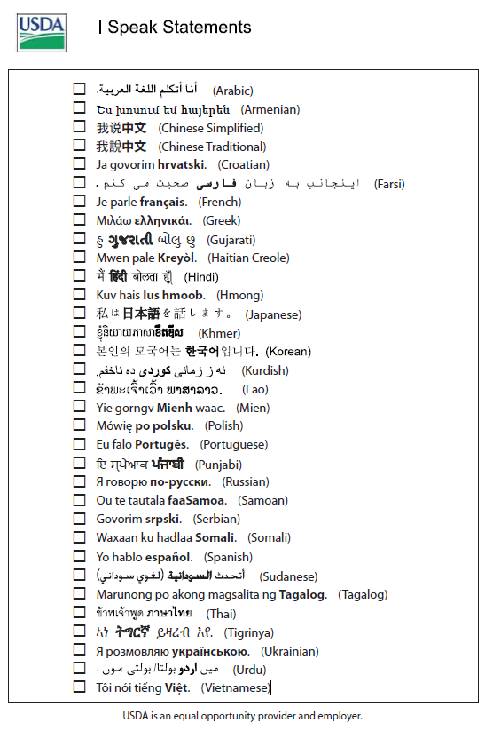

Student Name: __________________________________________
School: ________________________________________________ Grade: ___________

Instructions for School Districts
Free and Reduced Price School Meals Application and Verification Forms School Year 2016-2017

This packet contains Massachusetts prototype forms:
Required information that must be provided to households:
- Notice of Direct Certification approval for free meals (to households with students that are matched via the Virtual Gateway)
- NEW Letter to Households/Frequently Asked Questions
- NEW How to Apply for Free and Reduced Price School Meals
- NEW Massachusetts Free and Reduced Price School Meals Family Application–SY 2016-2017
- Notice to Households of Approval/Denial of Benefits

Required Verification documents and information for households selected for verification of eligibility information materials:
- Notification of Selection for Verification of Eligibility - if household is not directly verified via the Virtual Gateway
- Letter of Verification Results – Provide to ALL households selected for verification (direct verification or paper method)

Optional application-related materials that should be provided to households:
- Sharing Information with Medicaid/CHIP
- Sharing Information with Other Programs: In most instances, LEAs may not share eligibility information without consent. ESE highly recommends including this document as part of the meal benefit package
- USDA’s “I SPEAK Statements” document – to assist in determining the language needs of households

The pages are designed to be printed on 8½” by 11” paper. Some pages may be printed front and back. You will need to identify the benefits that are offered in your school, such as afterschool snacks. The [bold, bracketed fields] indicate where you need to insert school district specific information. For example, you must include your district’s no-charge telephone number for verification assistance on the verification materials. This prototype application package includes information regarding the exclusion of housing allowance for those in the Military Housing Privatization Initiative. If this is not pertinent to your school district, please modify as appropriate. A hearing procedure guidelines document is also included for the district to use to develop their district specific hearing procedures.

If you have questions, contact:

Ebonique Faria
School Nutrition Program Review Coordinator
Office for Food and Nutrition Programs
Massachusetts Department of Elementary and Secondary Education
75 Pleasant Street
Malden, MA 02148

781-338-6461

All households must be notified of their eligibility status. Households with children who are denied benefits must be given written notification of the denial. The notification must advise the household of the reason for the denial of benefits, the right to appeal, instruction on how to appeal, and a statement that the family may re-apply for free and reduced price meal benefits at any time during the school year. Households with children who are approved for free or reduced price benefits may be notified in writing or orally.

Frequently asked questions about
free and reduced price school meals
Dear Parent/Guardian:

Children need healthy meals to learn. Westwood Public Schools offers healthy meals every school day. Lunch costs $3.25 at High School, $3.00 at the Middle School, $2.75 at the Elementary. Your children may qualify for free meals or for reduced price meals. Reduced price is $.40 for lunch. This packet includes an application for free or reduced price meal benefits, and a set of detailed instructions. Below are some common questions and answers to help you with the application process.
- Who can get free OR REDUCED PRICE meals?
  - All children in households receiving benefits from MA SNAP or MA TANF are eligible for free meals.
  - Foster children that are under the legal responsibility of a foster care agency or court are eligible for free meals.
  - Children participating in their school’s Head Start program are eligible for free meals.
  - Children who meet the definition of homeless, runaway, or migrant are eligible for free meals.
  - Children may receive free or reduced price meals if your household’s income is within the limits on the Federal Income Eligibility Guidelines. Your children may qualify for free or reduced price meals if your household income falls at or below the limits on this chart.

FEDERAL ELIGIBILITY INCOME CHART For School Year 2016-2017
Household size | Yearly | Monthly | Weekly
1 | $21,978 | $1,832 | $ 423
2 | $29,637 | $2,470 | $ 570
3 | $37,296 | $3,108 | $ 718
4 | $44,955 | $3,747 | $ 865
5 | $52,614 | $4,385 | $1,012
6 | $60,273 | $5,023 | $1,160
7 | $67,951 | $5,663 | $1,307
8 | $75,647 | $6,304 | $1,455
Each additional person: | $+7,696 | $ +642 | $ +148
- HOW DO I KNOW IF MY CHILDREN QUALIFY AS homeless, MIGRANT, OR RUNAWAY? Do the members of your household lack a permanent address? Are you staying together in a shelter, hotel, or other temporary housing arrangement? Does your family relocate on a seasonal basis? Are any children living with you who have chosen to leave their prior family or household? If you believe children in your household meet these descriptions and haven’t been told your children will get free meals, please call or e-mail Abigail Hanscom, Ahanscom@westwood.k12.ma.us.
- Do I need to fill out an application for each child? No. Use one Free and Reduced Price School Meals Application for all students in your household. We cannot approve an application that is not complete, so be sure to fill out all required information. Return the completed application to: Westwood High School 220 Nahatan Street Westwood, MA 02090.
- SHOULD I FILL OUT AN APPLICATION IF I RECEIVED A LETTER THIS SCHOOL YEAR SAYING MY CHILDREN ARE ALREADY APPROVED FOR FREE MEALS? No, but please read the letter you got carefully and follow the instructions. If any children in your household were missing from your eligibility notification, contact Sandy Mack, smack@westwood.k12.ma.us. 781-326-7500 X 1301 immediately.
- MY CHILD’S APPLICATION WAS APPROVED LAST YEAR. DO I NEED TO FILL OUT A NEW ONE? Yes. Your child’s application is only good for that school year and for the first few days of this school year. You must send in a new application unless the school told you that your child is eligible for the new school year.
- I GET WIC. CAN MY CHILDREN GET FREE MEALS? Children in households participating in WIC may be eligible for free or reduced price meals. Please send in an application.
- Will the information I give be checked? Yes. We may also ask you to send written proof of the household income you report.
- If I don’t qualify now, may I apply later? Yes, you may apply at any time during the school year. For example, children with a parent or guardian who becomes unemployed may become eligible for free and reduced price meals if the household income drops below the income limit.
- What if I disagree with the school’s decision about my application? You should talk to school officials. You also may ask for a hearing by calling or writing to: Vinicio Cordon, Food director. Vcordon@westwood.k12.ma.us.
- May I apply if someone in my household is not a U.S. citizen? Yes. You, your children, or other household members do not have to be U.S. citizens to apply for free or reduced price meals.
- What if my income is not always the same? List the amount that you normally receive. For example, if you normally make $1000 each month, but you missed some work last month and only made $900, put down that you made $1000 per month. If you normally get overtime, include it, but do not include it if you only work overtime sometimes. If you have lost a job or had your hours or wages reduced, use your current income.
- WHAT IF SOME HOUSEHOLD MEMBERS HAVE NO INCOME TO REPORT? Household members may not receive some types of income we ask you to report on the application, or may not receive income at all. Whenever this happens, please write a 0 in the field. However, if any income fields are left empty or blank, those will also be counted as zeroes. Please be careful when leaving income fields blank, as we will assume you meant to do so.
- We are in the military. do we REPORT OUR INCOME DIFFERENTLY? Your basic pay and cash bonuses must be reported as income. If you get any cash value allowances for off-base housing, food, or clothing, or receive Family Subsistence Supplemental Allowance payments, it must also be included as income. However, if your housing is part of the Military Housing Privatization Initiative, do not include your housing allowance as income. Any additional combat pay resulting from deployment is also excluded from income.
- WHAT IF THERE ISN’T ENOUGH SPACE ON THE APPLICATION FOR MY FAMILY? List any additional household members on a separate piece of paper, and attach it to your application. Contact Sandy Mack, smack@westwood.k12.ma.us or 781-326-7500 X 1301 to receive a second application.
- My family needs more help. Are there other programs we might apply for? To find out how to apply for MA SNAP or other assistance benefits, contact your local assistance office or call the MA SNAP Hotline at 1-866-950-3663.
If you have other questions or need help, call 781-326-7500x1301.

Sincerely,

Notice of Direct Certification
Dear Parent/Guardian:
We want to let you know that the child(ren) listed below will receive free lunches, breakfasts, and snacks at school because they receive MA SNAP or MA TANF.

Name of Child | Name of School

If there are other children in your household who aren’t listed above, they also qualify for free meals.
Please contact the school your child/children attend in the following situations:
- If there are other children in your household who are not listed above and you would like them to receive free meals at school
- You do not want your children to have free meals
- You have any additional questions
Vincio Cordon
781-326-7500 x 4351
Vcordon@westwood.k12.ma.us
Sincerely,
Vincio Cordon

Non-Discrimination Statement: This explains what to do if you believe you have been treated unfairly.
In accordance with Federal civil rights law and U.S. Department of Agriculture (USDA) civil rights regulations and policies, the USDA, its Agencies, offices, and employees, and institutions participating in or administering USDA programs are prohibited from discriminating based on race, color, national origin, sex, disability, age, or reprisal or retaliation for prior civil rights activity in any program or activity conducted or funded by USDA.

Persons with disabilities who require alternative means of communication for program information (e.g. Braille, large print, audiotape, American Sign Language, etc.), should contact the Agency (State or local) where they applied for benefits. Individuals who are deaf, hard of hearing or have speech disabilities may contact USDA through the Federal Relay Service at (800) 877-8339. Additionally, program information may be made available in languages other than English.

To file a program complaint of discrimination, complete the USDA Program Discrimination Complaint Form, (AD-3027) found online at: http://www.ascr.usda.gov/complaint_filing_cust.html, and at any USDA office, or write a letter addressed to USDA and provide in the letter all of the information requested in the form. To request a copy of the complaint form, call (866) 632-9992. Submit your completed form or letter to USDA by:

(1) mail: U.S. Department of Agriculture
Office of the Assistant Secretary for Civil Rights
1400 Independence Avenue, SW
Washington, D.C. 20250-9410;
(2) fax: (202) 690-7442; or
(3) email: program.intake@usda.gov.
This institution is an equal opportunity provider.

Sharing Information With Medicaid/CHIP
Dear Parent/Guardian:
If your children get free or reduced price school meals, they may also be able to get free or low-cost health insurance through Medicaid or the State Children's Health Insurance Program (CHIP). Children with health insurance are more likely to get regular health care and are less likely to miss school because of sickness.
Because health insurance is so important to children’s well-being, the law allows us to tell Medicaid and CHIP that your children are eligible for free or reduced price meals, unless you tell us not to. Medicaid and CHIP only use the information to identify children who may be eligible for their programs. Program officials may contact you to offer to enroll your children. Filling out the Free and Reduced Price School Meals Application does not automatically enroll your children in health insurance.
If you do not want us to share your information with Medicaid or CHIP, fill out the form below and send in.
(Sending in this form will not change whether your children get free or reduced price meals).

- No! I DO NOT want information from my Free and Reduced Price School Meals Application shared with Medicaid or the State Children's Health Insurance Program.
If you checked no, fill out the form below to ensure that your information is NOT shared for the child(ren) listed below:
Child's Name: ___________________________________________School:
Child's Name: ___________________________________________School:
Child's Name: ___________________________________________School:
Child's Name: ___________________________________________School:
Signature of Parent/Guardian: _______________________________________Date:
Printed Name:
Address:

For more information, you may call Sandy Mackat 781-326-7500 X 1301 or e-mail: smack@westwood.k12.ma.us].
Return this form to: 220 Nahatan Street Westwood, MA 02090 by October 17, 2016.

Sharing Information With Other Programs
Dear Parent/Guardian:
To save you time and effort, the information you gave on your Free and Reduced Price School Meals Application may be shared with other programs for which your children may qualify. For the following programs, we must have your permission to share your information. Sending in this form will not change whether your children get free or reduced price meals.

- Yes! I DO want school officials to share information from my Free and Reduced Price School Meals Application with [name of program specific to your school].
- Yes! I DO want school officials to share information from my Free and Reduced Price School Meals Application with [name of program specific to your school].
- Yes! I DO want school officials to share information from my Free and Reduced Price School Meals Application with [name of program specific to your school].

If you checked yes to any or all of the boxes above, fill out the form below to ensure that your information is shared for the child(ren) listed below. Your information will be shared only with the programs you checked.
Child's Name: ___________________________________________School:
Child's Name: ___________________________________________School:
Child's Name: ___________________________________________School:
Child's Name: ___________________________________________School:
Signature of Parent/Guardian: _____________________________________________Date:
Printed Name:
Address:

For more information, you may call Sandy Mack at 781-326-7500 X 1301 or e-mail at smack@westwood.k12.ma.us
Return this form to: 220 Nahatan Streeet Westwood, MA 02090 by October 17, 2016

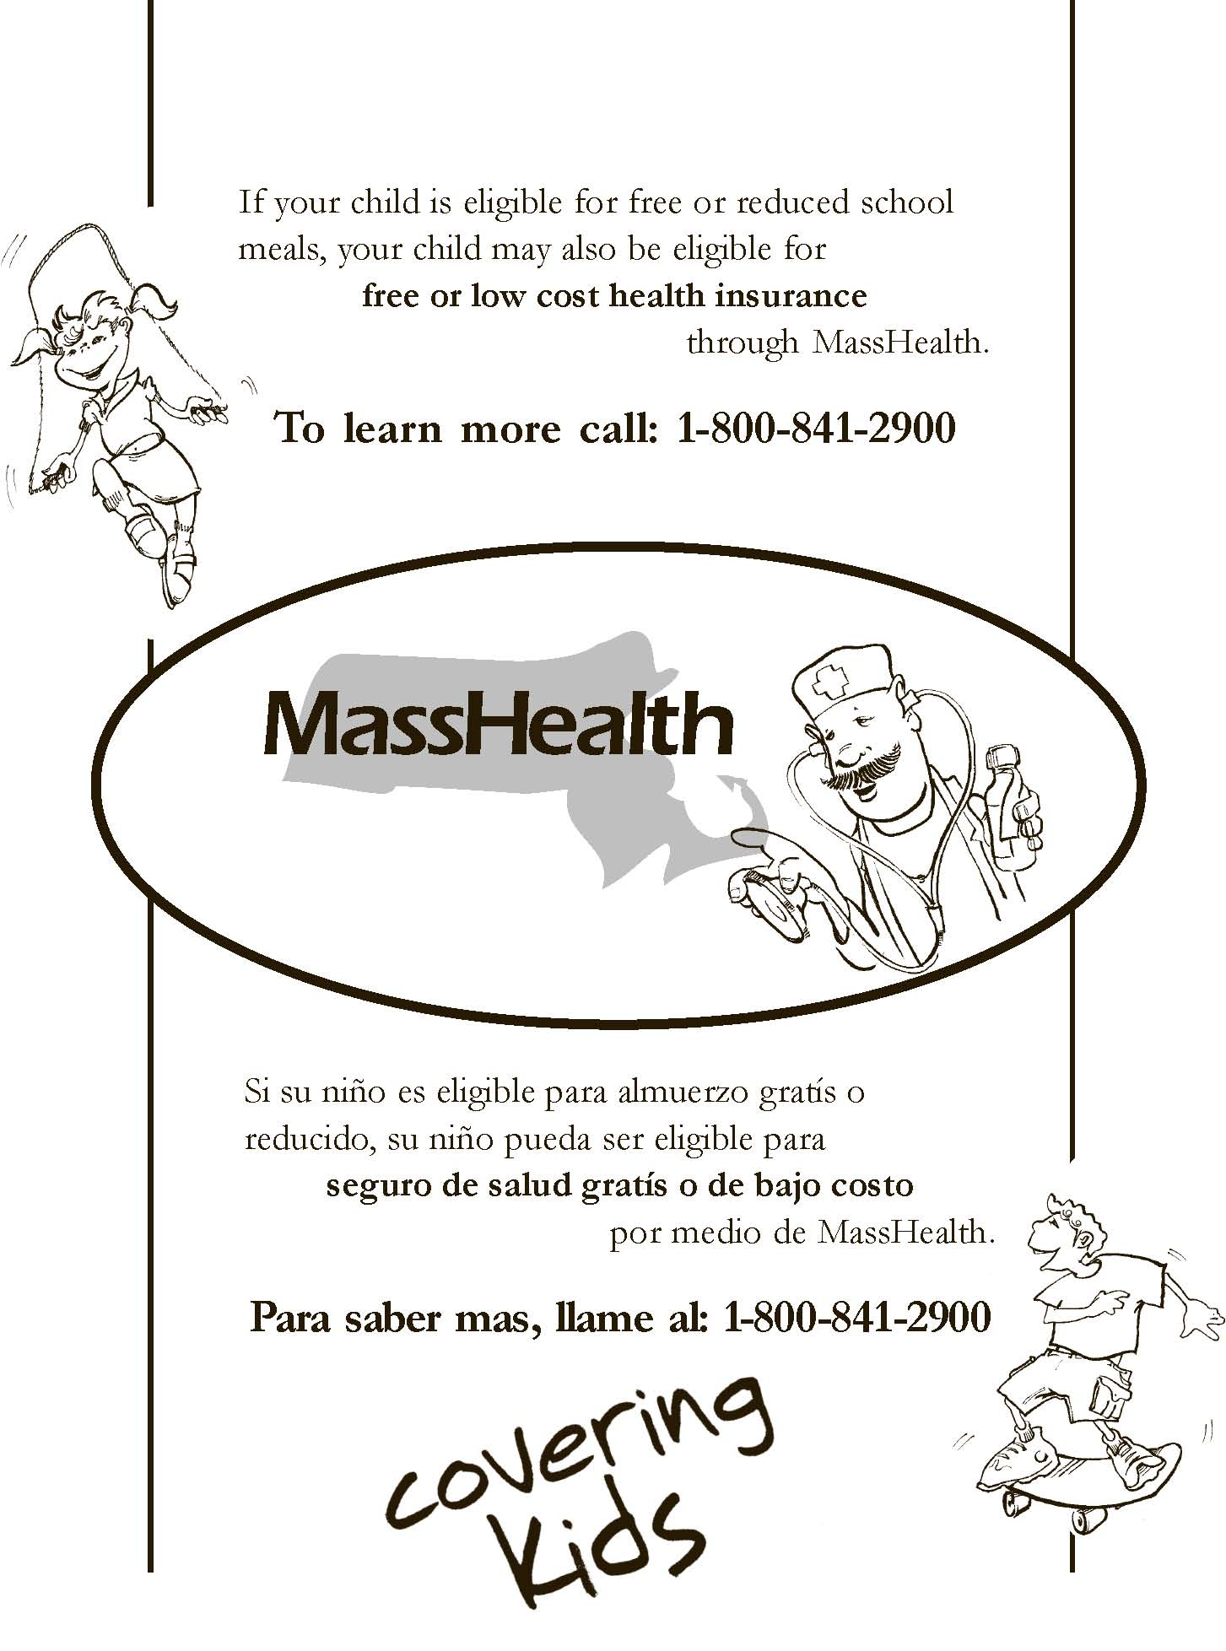

Notice To Households of
Approval/Denial of benefits

Dear Parent/Guardian:
You applied for free or reduced-meals for the following child(ren);
_______________________________________ _____________________________________
_______________________________________ _____________________________________
_______________________________________ _____________________________________
Your application was:
- Approved for free meals
- Approved for reduced price meals at $ __________ for lunch, $ ____________ for breakfast, and $ ____________ for snacks
- Denied for the following reason(s):
  - Income over the allowable amount
  - Incomplete application because ___________________________________________________
  - Other _______________________________________________________________________

If you do not agree with the decision, you may discuss it with Westwood Public Schools at 781-326-7500 X 1301 or smack@westwood.k12.ma.us. If you wish to review the decision further, you have a right to a fair hearing. This can be done by calling or writing the following official:

Name: ____________________________________________________________________________________
Address: _________________________________________________________________________________
Phone Number: ____________________________________ E-mail: ________________________________
Sincerely,

[signature]

____________________________________________________________________________________________
Name Title Date
_______________________________________________________________________________________________________
The Richard B. Russell National School Lunch Act requires the information on this application. You do not have to give the information, but if you do not, we cannot approve your child for free or reduced price meals. You must include the last four digits of the social security number of the adult household member who signs the application. The last four digits of the social security number is not required when you apply on behalf of a foster child or you list a Supplemental Nutrition Assistance Program (SNAP), Temporary Assistance for Needy Families (TANF) Program or Food Distribution Program on Indian Reservations (FDPIR) case number or other FDPIR identiﬁer for your child or when you indicate that the adult household member signing the application does not have a social security number. We will use your information to determine if your child is eligible for free or reduced price meals, and for administration and enforcement of the lunch and breakfast programs. We MAY share your eligibility information with education, health, and nutrition programs to help them evaluate, fund, or determine beneﬁts for their programs, auditors for program reviews, and law enforcement officials to help them look into violations of program rules.

In accordance with Federal civil rights law and U.S. Department of Agriculture (USDA) civil rights regulations and policies, the USDA, its Agencies, offices, and employees, and institutions participating in or administering USDA programs are prohibited from discriminating based on race, color, national origin, sex, disability, age, or reprisal or retaliation for prior civil rights activity in any program or activity conducted or funded by USDA.

Persons with disabilities who require alternative means of communication for program information (e.g. Braille, large print, audiotape, American Sign Language, etc.), should contact the Agency (State or local) where they applied for benefits. Individuals who are deaf, hard of hearing or have speech disabilities may contact USDA through the Federal Relay Service at (800) 877-8339. Additionally, program information may be made available in languages other than English.

To file a program complaint of discrimination, complete the USDA Program Discrimination Complaint Form, (AD-3027) found online at: http://www.ascr.usda.gov/complaint_filing_cust.html, and at any USDA office, or write a letter addressed to USDA and provide in the letter all of the information requested in the form. To request a copy of the complaint form, call (866) 632-9992. Submit your completed form or letter to USDA by:

(1) mail: U.S. Department of Agriculture
Office of the Assistant Secretary for Civil Rights
1400 Independence Avenue, SW
Washington, D.C. 20250-9410;
(2) fax: (202) 690-7442; or
(3) email: program.intake@usda.gov
This institution is an equal opportunity provider.

We Must Check Your Application
You must send the information we need, or contact [name] by [date], or your child(ren) will stop getting free or reduced price meals.

School: _______________________________________________________________ Date: __________________

Dear ___________________________________________________:

We are checking your Free and Reduced Price School Meals Application. Federal rules require that we do this to make sure only eligible children get free or reduced price meals. You must send us information to prove that [name(s) of child(ren)][is/are] eligible.

If possible, send copies, not original papers. If you do send originals, they will be sent back to you only if you ask.

1. If you were receiving benefits from MA SNAP, or MA TAFDC when you applied for free or reduced price meals, or at any time since then, send us a copy of one of these:

- MA SNAP or MA TAFDC Certification Notice that shows dates of certification.
- Letter from MA SNAP or MA TAFDC office that shows dates of certification.
- Do not send your EBT card.

2. If you get this letter for a homeless, migrant, or runaway child, please contact Westwood Public Schools, Abigail Hanscom, Ahanscom@westwood.k12.ma.us for help.

3. If the child is a Foster Child:
Provide written documentation that verifies the child is the legal responsibility of the agency or court or provide the name and contact information for a person at the agency or court who can verify that the child is a foster child.

4. If no one in your household receives MA SNAP or MA TAFDC benefits:
Send this page along with papers that show the amount of money your household gets from each source of income. The papers you send must show the name of the person who received the income, the date it was received, how much was received, and how often it was received. Send information to: 220 Nahatan Street Westwood, MA 02090

Acceptable papers include:
- Jobs: Paycheck stub or pay envelope that shows the amount and how often the pay is received; letter from employer stating gross wages and how often you are paid; or, if you work for yourself, business or farming papers, such as ledger or tax books.
- Social Security, Pensions, or Retirement: Social Security retirement benefit letter, statement of benefits received, or pension award notice.
- Unemployment, Disability, or Worker’s Comp: Notice of eligibility from State employment security office, check stub, or letter from the Worker’s Compensation’s office.
- Welfare Payments: Benefit letter from the MA TAFDC office.
- Child Support or Alimony: Court decree, agreement, or copies of checks received.
- Other income (such as rental income): Information that shows the amount of income received, how often it is received, and the date received.
- No income: A brief note explaining how you provide food, clothing, and housing for your household, and when you expect an income.
- Military Housing Privatization Initiative: Letter or rental contract showing that your housing is part of the Military Privatized Housing Initiative.
- Timeframe of Acceptable Income Documentation: Please submit proof of one month’s income; you could use the month prior to application, the month you applied, or any month after that.

If you have questions or need help, please call [name] at [phone number]. The call is free. [Toll free or reverse charge explanation]. You may also e-mail us at [e-mail address].

Sincerely,

[signature]

The Richard B. Russell National School Lunch Act requires the information on this application. You do not have to give the information, but if you do not, we cannot approve your child for free or reduced price meals. You must include the last four digits of the social security number of the adult household member who signs the application. The last four digits of the social security number is not required when you apply on behalf of a foster child or you list a Supplemental Nutrition Assistance Program (SNAP), Temporary Assistance for Needy Families (TANF) Program or Food Distribution Program on Indian Reservations (FDPIR) case number or other FDPIR identiﬁer for your child or when you indicate that the adult household member signing the application does not have a social security number. We will use your information to determine if your child is eligible for free or reduced price meals, and for administration and enforcement of the lunch and breakfast programs. We MAY share your eligibility information with education, health, and nutrition programs to help them evaluate, fund, or determine beneﬁts for their programs, auditors for program reviews, and law enforcement officials to help them look into violations of program rules.

In accordance with Federal civil rights law and U.S. Department of Agriculture (USDA) civil rights regulations and policies, the USDA, its Agencies, offices, and employees, and institutions participating in or administering USDA programs are prohibited from discriminating based on race, color, national origin, sex, disability, age, or reprisal or retaliation for prior civil rights activity in any program or activity conducted or funded by USDA.

Persons with disabilities who require alternative means of communication for program information (e.g. Braille, large print, audiotape, American Sign Language, etc.), should contact the Agency (State or local) where they applied for benefits. Individuals who are deaf, hard of hearing or have speech disabilities may contact USDA through the Federal Relay Service at (800) 877-8339. Additionally, program information may be made available in languages other than English.

To file a program complaint of discrimination, complete the USDA Program Discrimination Complaint Form, (AD-3027) found online at: http://www.ascr.usda.gov/complaint_filing_cust.html, and at any USDA office, or write a letter addressed to USDA and provide in the letter all of the information requested in the form. To request a copy of the complaint form, call (866) 632-9992. Submit your completed form or letter to USDA by:

(1) mail: U.S. Department of Agriculture
Office of the Assistant Secretary for Civil Rights
1400 Independence Avenue, SW
Washington, D.C. 20250-9410;
(2) fax: (202) 690-7442; or
(3) email: program.intake@usda.gov.
This institution is an equal opportunity provider.

We Have Checked Your Application
School: _________________________________________________________________ Date: ____________

Dear _________________________________:

We checked the information you sent us to prove that [name(s) of child(ren)] are eligible for free or reduced price meals and have decided that:
- Your child(ren)’s eligibility has not changed.
- Starting [date], your child(ren)’s eligibility for meals will be changed from reduced price to free because your income is within the free meal eligibility limits. Your child(ren) will receive meals at no cost.
- Starting [date], your child(ren)’s eligibility for meals will be changed from free to reduced price because your income is over the limit. Reduced price meals cost [$] for lunch and [$] for breakfast.
- Starting [date], your child(ren) is/are no longer eligible for free or reduced price meals for the following reason(s):
___ Records show that no one in your household received MA SNAP or MA TANF benefits.
___ Records show that the child(ren) is/are not homeless, runaway, or migrant.
___ Your income is over the limit for free or reduced price meals.
___ You did not provide:_________________________________________________________________________________
___ You did not respond to our request.

Meals cost [$] for lunch and [$] for breakfast. If your household income goes down or your household size goes up, you may apply again. If you were previously denied benefits because no one in the household received MA SNAP, MA TANF or [FDPIR] benefits, you may reapply based on income eligibility. If you did not provide proof of current eligibility, you will be asked to do so if you reapply.

If you disagree with this decision, you may discuss it with [name] at [phone]. You also have the right to a fair hearing. If you request a hearing by [date], your child(ren) will continue to receive free or reduced price meals until the decision of the hearing official is made. You may request a hearing by calling or writing to: [name], [address], [phone number], or [e-mail].

Sincerely,

[signature]

The Richard B. Russell National School Lunch Act requires the information on this application. You do not have to give the information, but if you do not, we cannot approve your child for free or reduced price meals. You must include the last four digits of the social security number of the adult household member who signs the application. The last four digits of the social security number is not required when you apply on behalf of a foster child or you list a Supplemental Nutrition Assistance Program (SNAP), Temporary Assistance for Needy Families (TANF) Program or Food Distribution Program on Indian Reservations (FDPIR) case number or other FDPIR identiﬁer for your child or when you indicate that the adult household member signing the application does not have a social security number. We will use your information to determine if your child is eligible for free or reduced price meals, and for administration and enforcement of the lunch and breakfast programs. We MAY share your eligibility information with education, health, and nutrition programs to help them evaluate, fund, or determine beneﬁts for their programs, auditors for program reviews, and law enforcement officials to help them look into violations of program rules.

In accordance with Federal civil rights law and U.S. Department of Agriculture (USDA) civil rights regulations and policies, the USDA, its Agencies, offices, and employees, and institutions participating in or administering USDA programs are prohibited from discriminating based on race, color, national origin, sex, disability, age, or reprisal or retaliation for prior civil rights activity in any program or activity conducted or funded by USDA.

Persons with disabilities who require alternative means of communication for program information (e.g. Braille, large print, audiotape, American Sign Language, etc.), should contact the Agency (State or local) where they applied for benefits. Individuals who are deaf, hard of hearing or have speech disabilities may contact USDA through the Federal Relay Service at (800) 877-8339. Additionally, program information may be made available in languages other than English.

To file a program complaint of discrimination, complete the USDA Program Discrimination Complaint Form, (AD-3027) found online at: http://www.ascr.usda.gov/complaint_filing_cust.html, and at any USDA office, or write a letter addressed to USDA and provide in the letter all of the information requested in the form. To request a copy of the complaint form, call (866) 632-9992. Submit your completed form or letter to USDA by:

(1) mail: U.S. Department of Agriculture
Office of the Assistant Secretary for Civil Rights
1400 Independence Avenue, SW
Washington, D.C. 20250-9410;
(2) fax: (202) 690-7442; or
(3) email: program.intake@usda.gov

This institution is an equal opportunity provider.

Hearing Procedure Guidelines
Prior to initiating the hearing procedure, the parents or local school official may request a conference to provide an opportunity for the parent and school official to discuss the situation, present information and obtain an explanation of data submitted in the application or the decision rendered. The request for a conference shall not in any way prejudice or diminish the right to a fair hearing.

Each LEA is required to develop their own official hearing procedure that is inclusive of all listed below.

The hearing procedure provides for the following:
- A publicly announced, simple method for making an oral or written request.

- An opportunity to be assisted or represented by an attorney or other person.

- An opportunity to examine, prior to and during the hearing, any documents and records presented to support the decision under appeal.

- Reasonable promptness and convenience in scheduling a hearing and adequate notice as to the time and place of the hearing.

- An opportunity to present oral or documentary evidence and arguments supporting a position without undue interference.

- An opportunity to question or refute any testimony or other evidence and to confront and cross-examine any adverse witnesses.

- That the hearing is conducted and the decision made by a hearing official who did not participate in making the decision under appeal or any previously held conference regarding the meal benefit issuance process.

- That the decision of the hearing official be based in the oral and documentary evidence presented at the hearing and be made a part of the hearing record.

- That the parties concerned and any designated representative thereof be notified in writing of the decision of the hearing official and that the decision of the hearing official is binding.

- That for each hearing a written record be prepared, including the challenge or decision under appeal, any documentary evidence, a summary of any oral testimony presented at the hearing, the decision of the hearing official including the reasons thereof and a copy of the notification to the parties concerned of the hearing official's decision.

- That such written record be preserved for a period of 3 years after the close of the school year to which it pertains. These records shall be available for examination by the parties concerned or their representatives at any reasonable time and place during such period.

During the appeal and hearing procedure:
  - Children who have been denied benefits upon application shall not receive continued benefits during this period.

  - Children who have been approved for benefits but are subject to termination or reduction of benefits later in the same school year shall continue to receive benefits if an appeal of the adverse action has been made within the10-day advance notice period.

Advance notification shall be provided to families who receive a termination of benefits 10 calendar days prior to the actual termination. The notice shall advise households of: (1) the change; (2) the reason for the change; (3) the right to appeal the action within the 10-day advance notice period; (4) instructions on how to appeal and (5) the right to reapply any time during the school year. The reasons for ineligibility shall be properly documented and retained on file at the Local Educational Agency.

The Richard B. Russell National School Lunch Act requires the information on this application. You do not have to give the information, but if you do not, we cannot approve your child for free or reduced price meals. You must include the last four digits of the social security number of the adult household member who signs the application. The last four digits of the social security number is not required when you apply on behalf of a foster child or you list a Supplemental Nutrition Assistance Program (SNAP), Temporary Assistance for Needy Families (TANF) Program or Food Distribution Program on Indian Reservations (FDPIR) case number or other FDPIR identiﬁer for your child or when you indicate that the adult household member signing the application does not have a social security number. We will use your information to determine if your child is eligible for free or reduced price meals, and for administration and enforcement of the lunch and breakfast programs. We MAY share your eligibility information with education, health, and nutrition programs to help them evaluate, fund, or determine beneﬁts for their programs, auditors for program reviews, and law enforcement officials to help them look into violations of program rules.

In accordance with Federal civil rights law and U.S. Department of Agriculture (USDA) civil rights regulations and policies, the USDA, its Agencies, offices, and employees, and institutions participating in or administering USDA programs are prohibited from discriminating based on race, color, national origin, sex, disability, age, or reprisal or retaliation for prior civil rights activity in any program or activity conducted or funded by USDA.

Persons with disabilities who require alternative means of communication for program information (e.g. Braille, large print, audiotape, American Sign Language, etc.), should contact the Agency (State or local) where they applied for benefits. Individuals who are deaf, hard of hearing or have speech disabilities may contact USDA through the Federal Relay Service at (800) 877-8339. Additionally, program information may be made available in languages other than English.

To file a program complaint of discrimination, complete the USDA Program Discrimination Complaint Form, (AD-3027) found online at: http://www.ascr.usda.gov/complaint_filing_cust.html, and at any USDA office, or write a letter addressed to USDA and provide in the letter all of the information requested in the form. To request a copy of the complaint form, call (866) 632-9992. Submit your completed form or letter to USDA by:

(1) mail: U.S. Department of Agriculture
Office of the Assistant Secretary for Civil Rights
1400 Independence Avenue, SW
Washington, D.C. 20250-9410;
(2) fax: (202) 690-7442; or
(3) email: program.intake@usda.gov

This institution is an equal opportunity provider.

