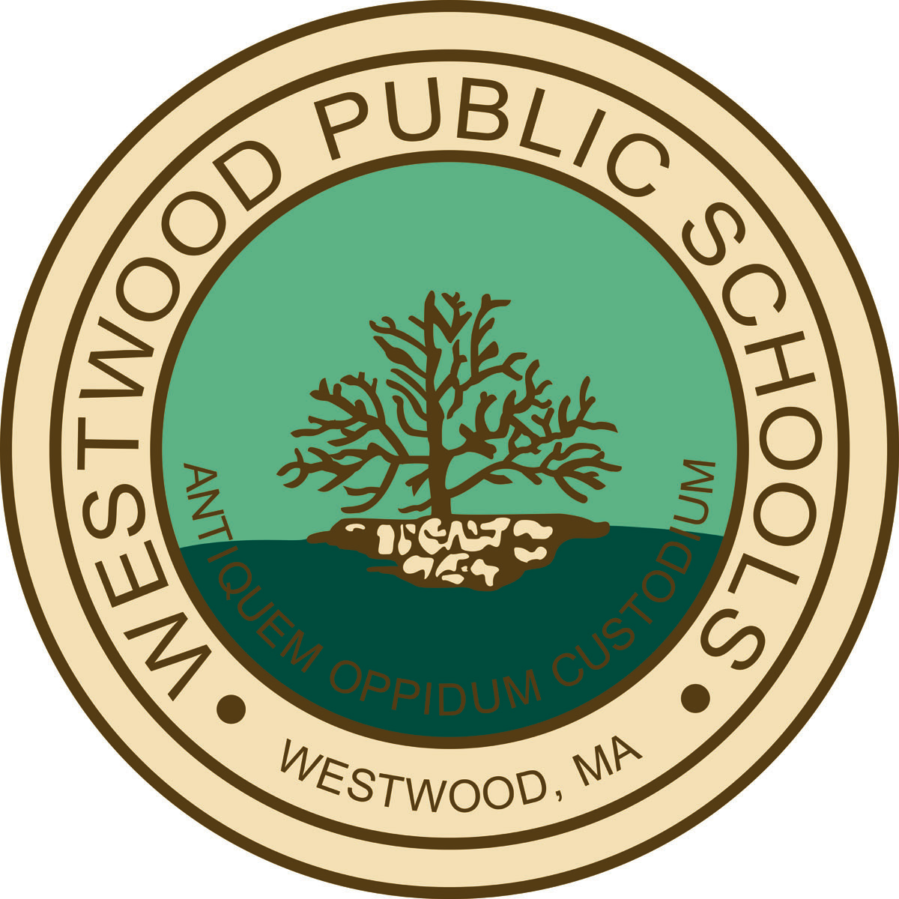

The Westwood Performing Arts Department provides an environment in which students develop the skills and capacity to create, respond, and perform. Whether engaging in the arts as a performer, director, composer, writer, designer, or technician, our students develop the processes and skills critical to the arts:

Create
- Engage in the creative problem solving process
- Develop technique and craft with increasing proficiency
- Make discoveries about one’s self and the world

Respond
- Listen and see critically
- Critique one’s own work and the work of others
- Recognize and appreciate a wide variety of styles in the arts

Perform
- Communicate ideas and feelings through performance or exhibition
- Take risks
- Present something new as an individual or a collaborator

We equally invite all of our community members-both within the school and the larger community- to engage in and experience the richness of being an audience member.

