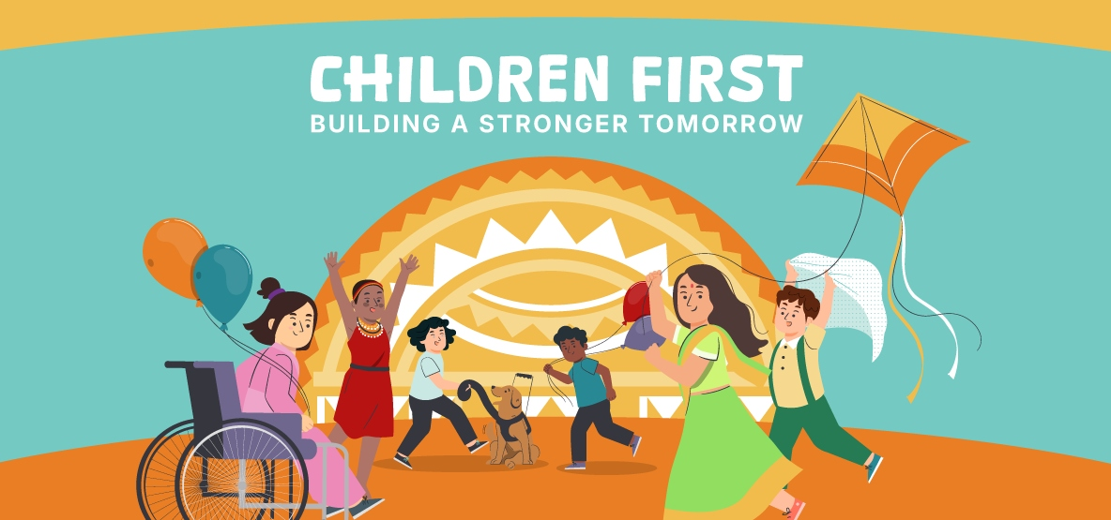

COMMUNITY DINNER

Wednesday, December 3rd from 6PM to 8PM in the Sheehan Cafeteria

Dear Westwood School Community,

We are excited to invite you to a Community Dinner to celebrate Westwood’s commitment to Putting Children First! Putting Children First means prioritizing every student’s right to learn in an environment that supports their diverse needs, embraces their unique abilities, and fosters a sense of belonging. It means recognizing that when schools are designed to support students with disabilities, they become better places for all learners. Recognizing the well-being of children reflects the health and future of the entire society.

Please join us on Wednesday, December 3 from 6 PM to 8PM in the Sheehan Cafeteria. At this gathering, we hope to foster connections among families, specifically to reinforce support of all of our children with disabilities and their families in Westwood.

This dinner is a wonderful opportunity to engage in meaningful conversation, share stories of our community and discuss ways we can collectively support each other. This event is for Adults only. Please RSVP here.


We look forward to seeing you there!

Warmly,

Kristen Evans, Principal

