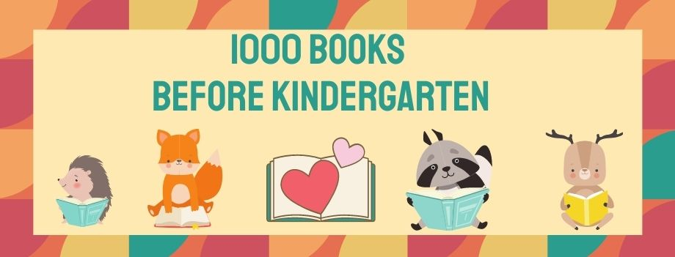

Westwood Public Library and Westwood Early Childhood Council invite families to join the “1,000 Books Before Kindergarten” program, a nationwide challenge that encourages parents and caregivers to regularly read aloud to their children. By reading just one book a night, families can reach the 1,000-book goal in three years and provide their children essential early literacy skills. Reading to children from an early age can help close the vocabulary gap and prepare children to enter kindergarten with the skills they need to succeed. Most importantly, sharing books with children promotes a lifelong love of books and reading.

How to Get Started
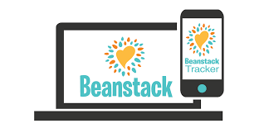
The 1,000 Books Before Kindergarten program is available to all families with children between the ages of birth and five years and starts November 15th, 2020.
1. Sign up with Beanstack: To participate, go to the Beanstack App or visit www.westwoodlibrary.beanstack.org and create an account. (Hint: if you participated in summer reading on Beanstack you already have an account and do not need to make a new one. Just log into your account and choose the 1000 Books Before Kindergarten challenge). Each registrant will receive a book and reusable bag to get started.
2. Log your Reading: Keep track of all the books you and your child read together. This can be as simple as hash marks on a post it note or as sentimental as a list of titles in a keepsake notebook! In the Beanstack app, you will have the opportunity to earn badges for milestones reached, from 1 book to 25 books, to 50 books, and so on, all the way up to 1000 books! Remember that even if your child wants to read the same book over and over again, you can count the book each time. You can also count books read at storytime, daycare and preschool.
3. Broaden your Reading Horizons: Looking for new books to read? The Westwood Children's Department is happy to find a stack of books just for you and your little one to enjoy together. Also be sure to visit one of the Little Free Libraries around town. The Westwood Early Childhood Council is hoping to turn these Little Free Libraries into Little Free Diverse Libraries with the Read in Color Project. We believe everyone should be able to see themselves in the pages of a book. We also know that books can be a window into experiences that are different from our own. By reading diverse books, we can increase understanding, empathy, and inclusion.
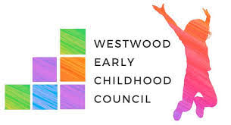
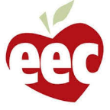
For more information, call the library at 781-320-1042 or email the children's department at wwdchildrens@gmail.com.

